Theoretical Layout

/var/folders/2f/w26sfqd55bx9kgm5csx6d1900000gp/T/com.microsoft.Word/WebArchiveCopyPasteTempFiles/p572

Phase angle and differential phase angle

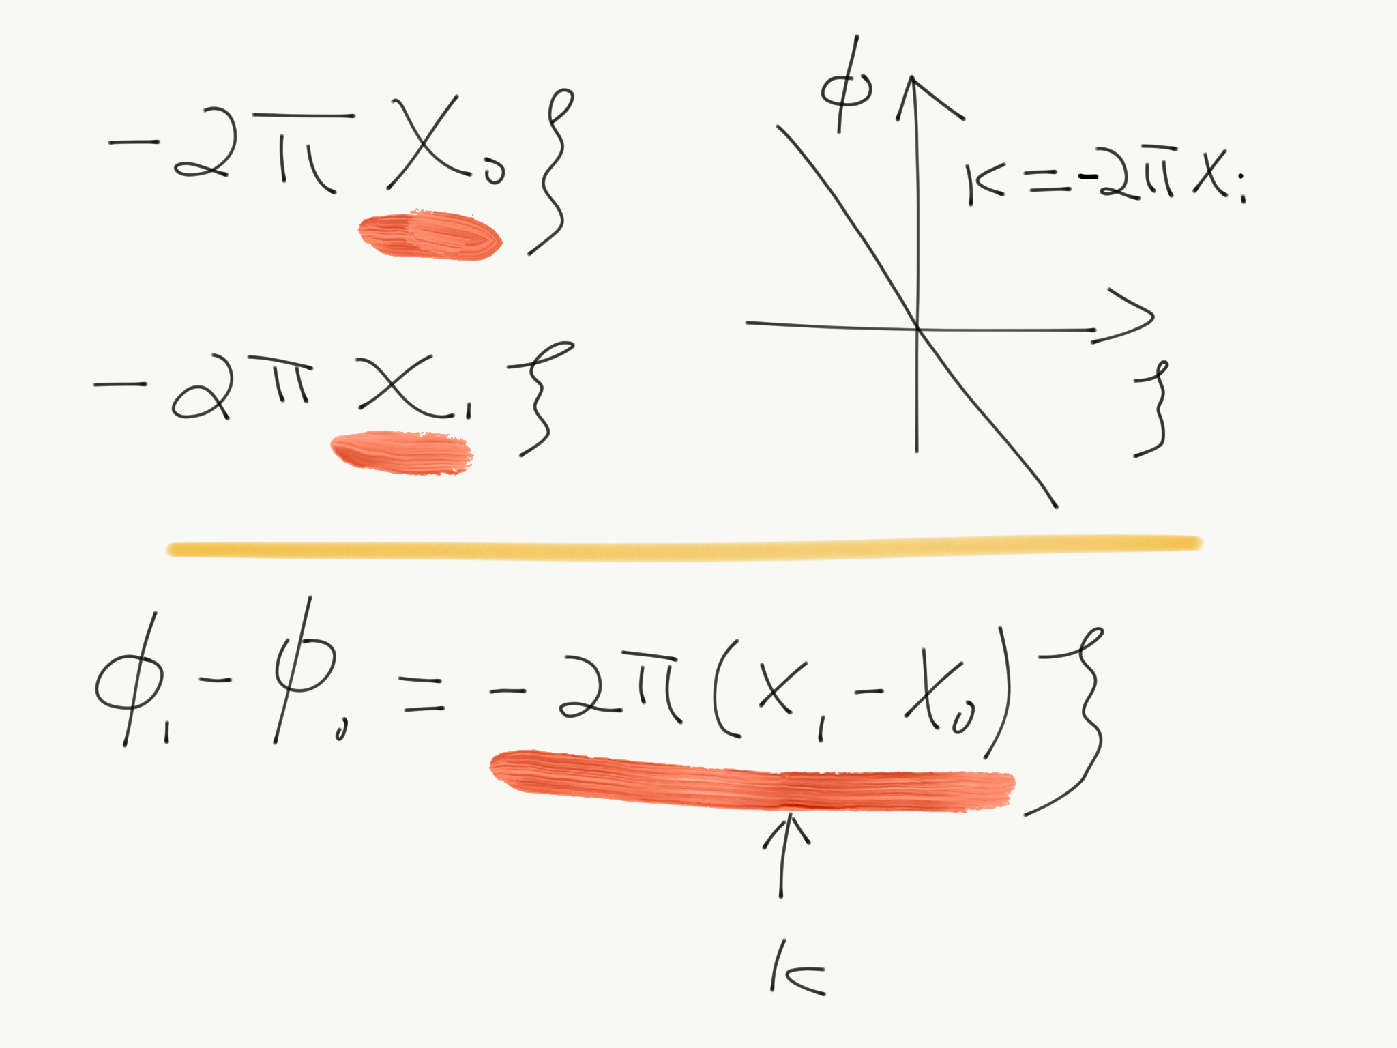

Relative shift

y-axis: differential phase angle

x-axis: FT frequency

Example

**Gaussian profile**

y = exp(-x.^2/5^2)

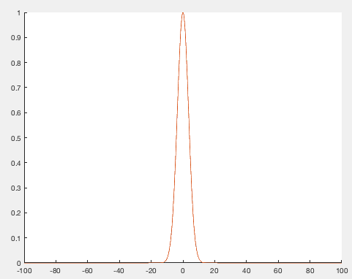

Overplot the Fourier Transform of 100 shifted Gaussians (shift ranges between -0.003 and 0.003):

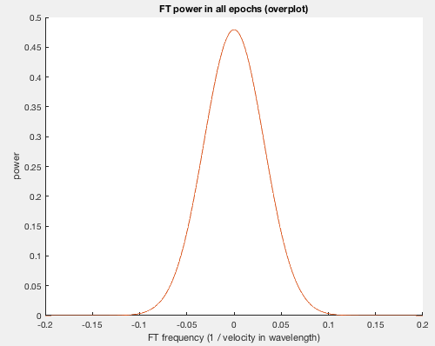

Differential Power:

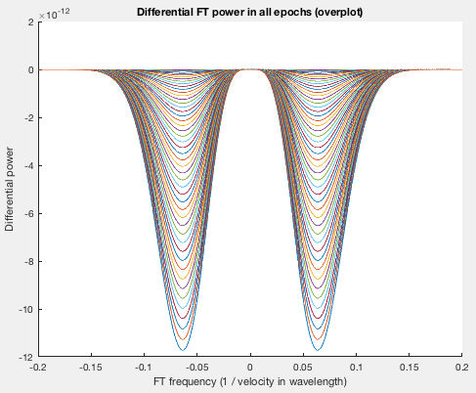

Phase angle:

Zoom-in of left panel

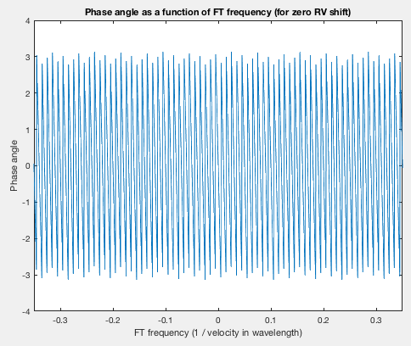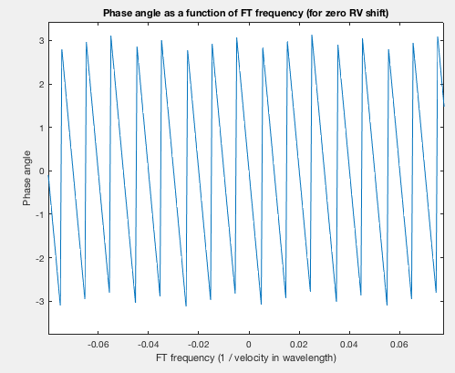

Differential phase angle:

Zoom-out of left panel

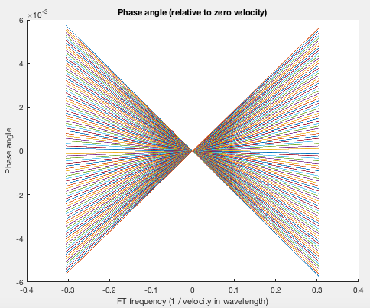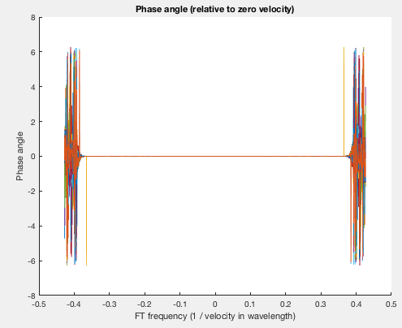

Linearity is only valid within a limited frequency range. Why?

* The range varies with the treatment of the profile, e.g.
  + vs )
  + Subtracting the “background”
  + Apodization?

Results:

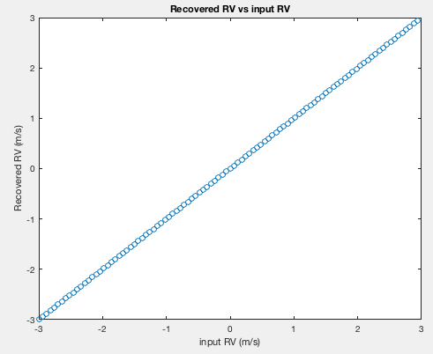

**Simulated profile with line deformation**

Simulated line profile

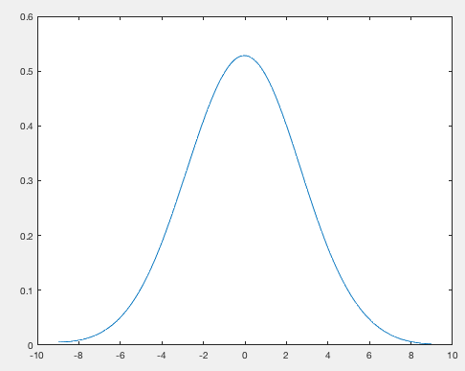

FT

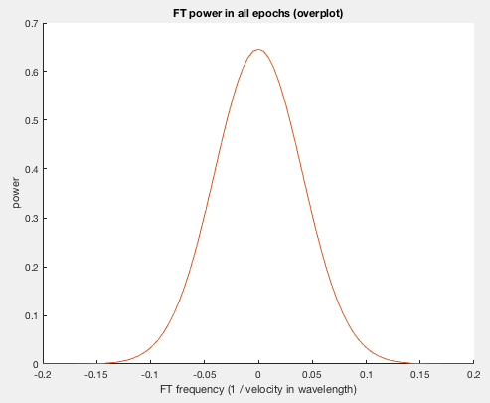

Differential Power:

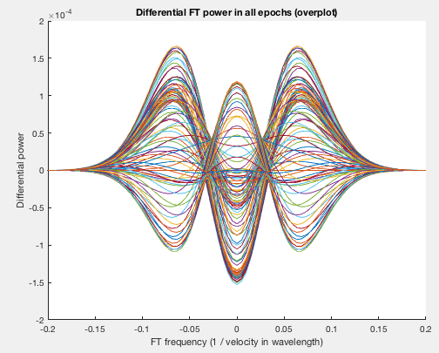

Phase angle:

Zoom-out of left panel

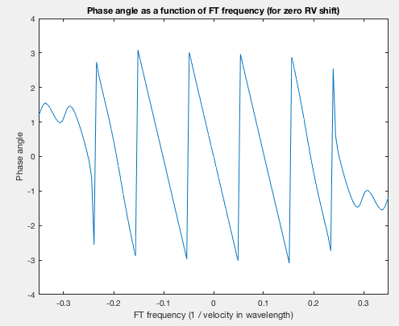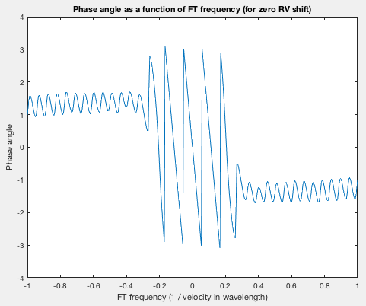

Differential phase angle:

Zoom-in of left panel

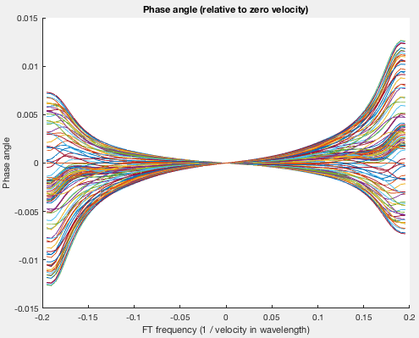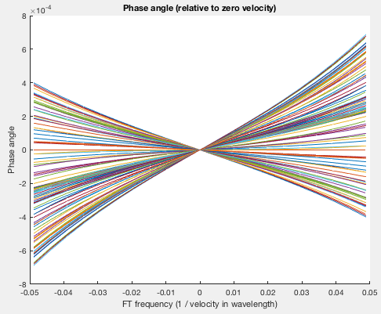

Didn’t expect linearity in the case of line deformation (without shift).

Results:

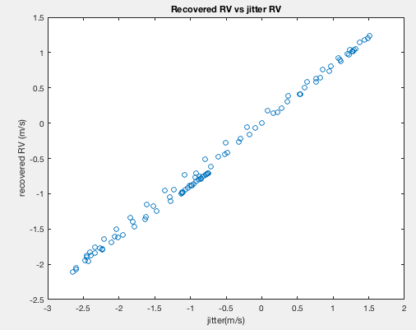

Slope = 0.8070; intercept = -0.0056.